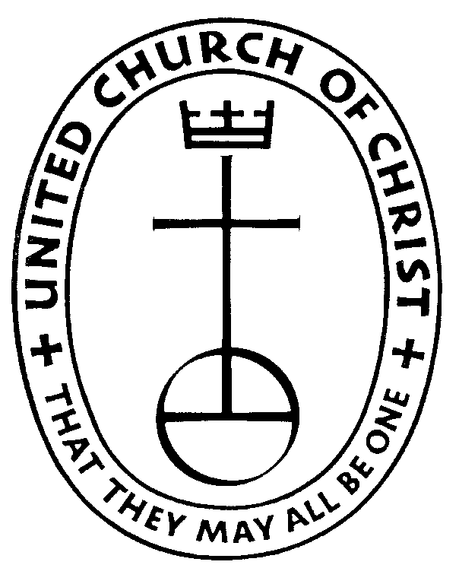

**Zion United Church of Christ**

113 1st Street, NE Waukon, IA 52172 563-568-3589

x.zionunitedchurch@mchsi.com

***Zion UCC Scholarship Application Requirements***

***and Instructions for completing the Application***

***Requirements to be eligible to apply for a Zion Scholarship:***

* Applicant must be a full time student
* Applicant must be a member of Zion United Church of Christ
* Applicant must pursuing an undergraduate degree or attending seminary school
* The Zion UCC Scholarship will only be awarded a maximum of 4 times

***Instructions for completing the Zion UCC Scholarship Application:***

1. Complete the entire application
2. Deadline to submit completed application is May 25, 2025.
3. Place your completed application in the attached envelope. Make sure you seal the envelope and write your name on the outside of the envelope where instructed.
4. You will need ***three*** (3) references; only one of which can be a teacher. Provide each reference with a copy of the *Scholarship Reference Evaluation* form as well as a return envelope.
5. If you have any questions, please feel free to contact any one of the Education Trust Committee members. Committee members are Gail Prestemon and Robert Rotach.